A43-AM,S- Peru-Moche-Ceramic Female Figurine-Cowled and Seated-100 BCE-400 CE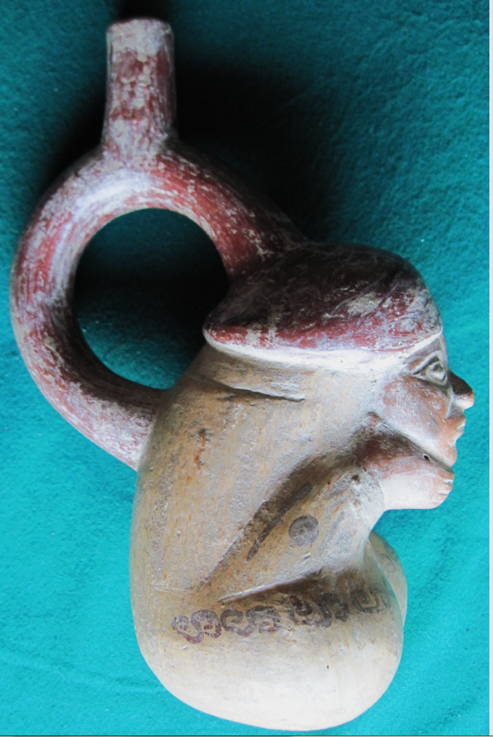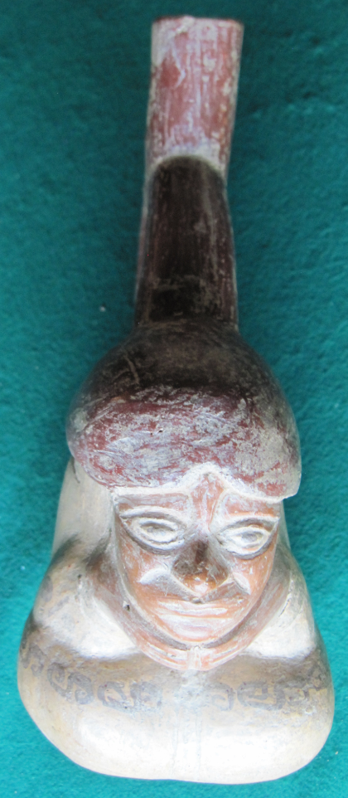 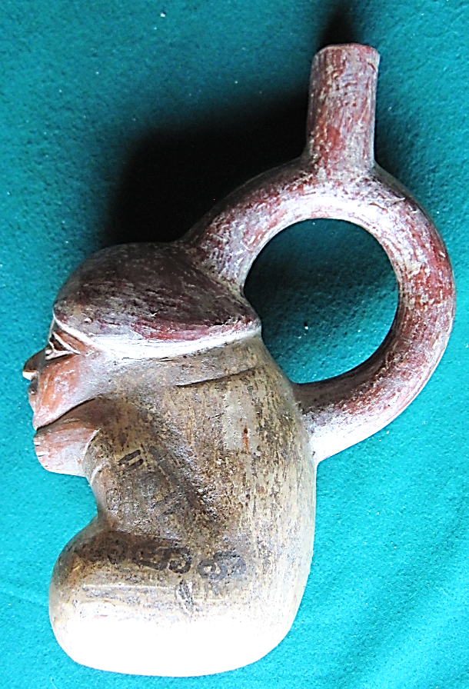 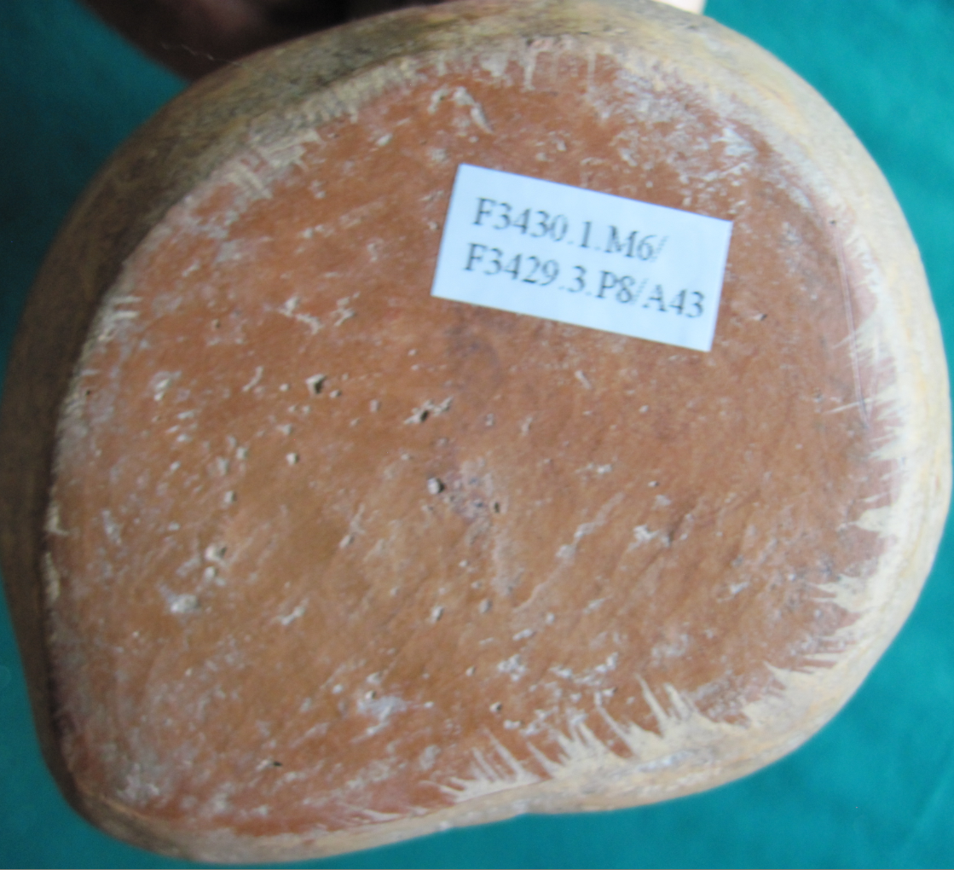 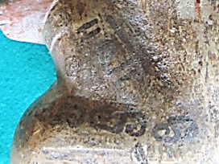

Figs. 1-5-AM,S- Peru-Moche-Ceramic Female Figurine-Cowled and Seated-100 BCE-400 CE

**Case no.: 7**

**Accession Number: A43**

**Formal Label:** Peru-Moche-Ceramic Female Figurine-Cowled and Seated-100 BCE-400 CE

**Display Description:** Moche ceramic of a cowled and seated female figurine wearing a crimson bi-lobal cap from the N Coast of Peru dating to the Moche II Period, 100 BCE-400 CE, with both hands under her chin suggesting that she is hiding San Pedro cactus balls prior to ingesting them as an hallucinogen. A series of four horizontal “S” shaped tattoos cover the length of both of her upper thighs, suggesting that these represent her request for abundant water to be achieved through communion with the realm of the dead and the ancestors.

**LC Classification: F3430.1.**

**Date or Time Horizon:** 100 BCE-400 CE

**Geographical Area:** N coastal Peru

**Map, GPS coordinates: -6.80139 -79.60202; 6º48'5" S 79º36'7.28" W.**

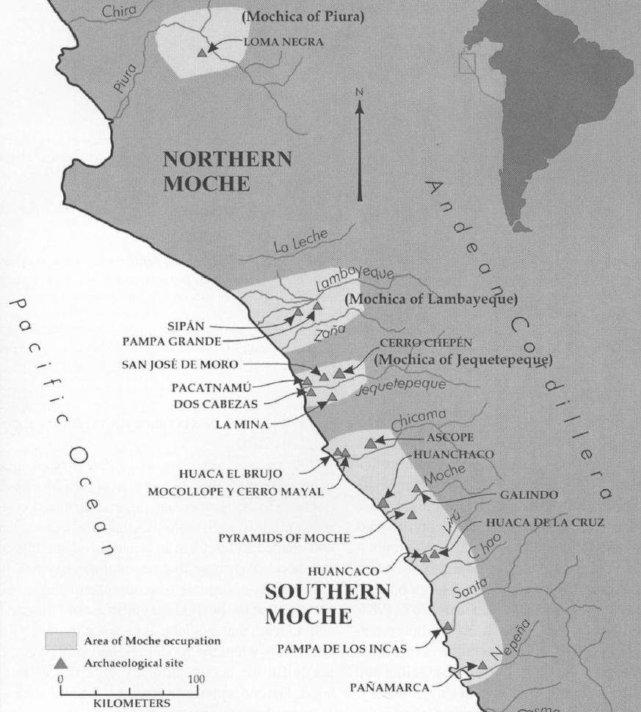

Fig. 6. Map of Moche regions as currently conceived and significant Moche sites. Map courtesy Moro Archaeological program.

**Cultural Affiliation:** Moche, Mochica

**Media:** clay; polychrome colors: red, cream, black, skin color

**Dimensions:** H mm; in

**Weight: gm; oz**

**Condition: original**

**Provenance:** unknown

**Discussion:** The practice of communing with the dead and the ancestors was well-established among the Moche using the San Pedro cactus and its hallucinatory properties (Sharon. 2000). This particular figurine provides suggestive iconography to support this thesis.

**References:**

Sharon, Douglas. 2000. Shamanism and the sacred cactus: ethnoarchaeolgical evidence for the San Pedro use in northern Peru. San Diego: San Diego Museum of Man.